IP AND SUBNETTING EXERCISES

1. Write the subnet, broadcast address and valid host range for the following:
   1. 192.168.100.17, with 4 bits of subnetting

Is a class C

11111111.11111111.11111111.11110000 🡪255.255.255.240

turning the last 8º into binary: 192.168.100.00010001

4 bits: 192.168.100.00010000🡪192.168.100.16

192.168.100.00011111🡪192.168.100.31

192.168.100.17🡪192.168.100.30

* 1. 192.168.100.66, with 3 bits of subnetting

Is a class C

we add 3 bits: 11111111.11111111.11111111.1110000🡪255.255.255.224

192.168.100.01000000🡪 192.168.100.64

192.168.100.01011111🡪 192.168.100.95

* 1. 172.16.10.5/20

Is a class B

11111111.11111111.11110000.00000000

172.16.10.5🡪 172.16.00001010.00000101

172.16.00000000.00000000🡪 172.16.0.0

172.16.00001111.11111111🡪 172.16.15.255

d. 172.16.10.33/255.255.252.0

1. You have been asked to create a subnet that supports 126 hosts. What subnet mask is the most efficient one? $2^{n}-2=126{ 2}^{7}-2=126$

7bits 🡪hosts in the mask 11111111.11111111.11111111.10000000

subnet mask is 255.255.255.128

1. Given the following
   1. Network address: 192.168.10.0

b. Subnet mask: 255.255.255.192

How many subnets are there? How many hosts? What are the valid subnets?

1. What is the problem in this Network?

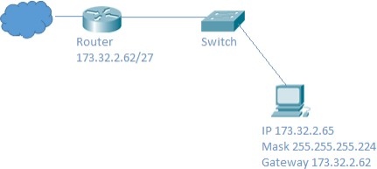

Mask 11111111.11111111.11111111.11100000/27

Network 1: 173.32.0.0 – 31

2: 173.32.0.32 – 63

3: 173.32.0.64 – 95

4: 173.32.0.96 – 127

1. XYZ Company would like to subnet its network so that there are five separate subnets. They will need 25 computers in each subnet. Complete the following table: NOTE: If you create more than five subnets, list the extra ones too.

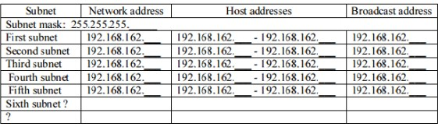

1. Imagine we want to create 1000 subnets with a /8 private network. Calculate the mask and the first, second, penultimate and last networks you would obtain.